Admixture Information (AI 6 MBS):
MasterLife® 300 Series Admixtures: DIN 1048 Test Method
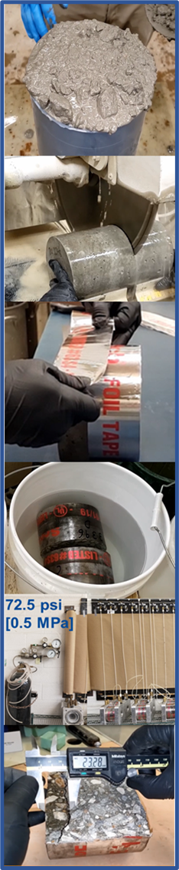
The DIN 1048 Part 5 Testing Concrete – Testing of hardened concrete (specimens prepared in mould) is a commonly specified, hydrostatic pressure test method found in project specifications for evaluating the performance of permeability-reducing admixtures.
A summary of this test method is shown below.
DIN 1048 (Hydrostatic Pressure)
Sample - 6 x 12 in. [150 x 305 mm] concrete cylinder
Procedure
- Cast and moist cure the concrete sample for 28 days.
- Cut a 4 in. [102 mm] thick slice from the hardened cylinder.
- Seal the sample sides with aluminum tape.
- Submerge in a water bath for 24 hours.
- Place the sample into the apparatus and apply water pressure.
  - 72.5 psi [0.5 MPa] for 3 days
- Break the sample in half
- Measure the depth of water penetration [in. or mm]

What the DIN Test Measures
Depth of water penetration into the concrete.
Interpretation of Results
- The results are strongly dependent on the conditioning method used which is not specified in the standard.
- This test method can be used to compare the depth of water penetration into concrete consisting of different proportions and/or treatments.

