Admixture Information (AI 7 MBS):
MasterLife® 300 Series Admixtures: CRD C48 Test Method
The Army Corps of Engineers CRD C48 Standard Test Method for Water Permeability of Concrete is a hydrostatic pressure test method found in some project specifications for evaluating the performance of permeability-reducing admixtures.
A summary of this test method is shown below.
CRD C48 (Hydrostatic Pressure)
Sample - 6 x 12 in. [150 x 305 mm] concrete cylinder
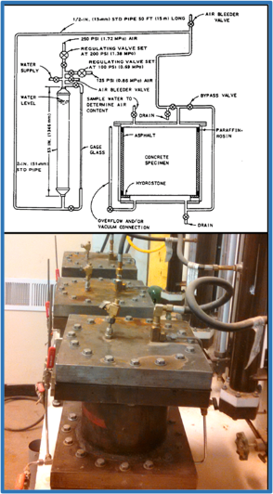
Procedure
- Cast and moist cure the concrete sample for 28 days.
  - Evaluate multiple samples given some variability in the test method
- Cut a 6 in. [150 mm] thick slice from the hardened cylinder.
- Place the sample into the apparatus and apply water pressure.
  - 200 psi [1.4 MPa] until flow reaches a steady-state [constant]
- Calculate the permeability.
- Report mixture proportions, treatments and dosages and permeability values [m/s].

What the CRD C48 Test Measures
Coefficient of permeability.
Interpretation of Results
- Exposure to water during testing may change the concrete microstructure (further hydration) during the test.
- Water permeability can be calculated which can be input into service life prediction models.
- This test method can be used to compare the water permeability of concrete consisting of different proportions and/or treatments.

