Admixture Information (AI 8 MBS):
MasterLife® 300 Series Admixtures: ASTM C1585 Test Method
The ASTM C1585 Standard Test Method for Measurement of Rate of Absorption of Water by Hydraulic Cement Concretes is a test method found in some project specifications for evaluating the performance of permeability-reducing admixtures.
A summary of this test method is shown below.
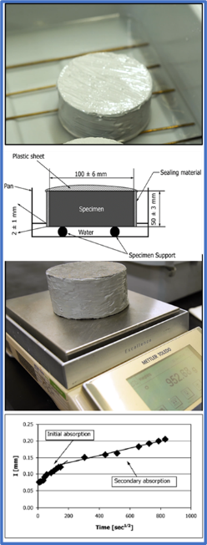
ASTM C1585 (Rate of Absorption)
Sample - 4 x 8 in. [100 x 205 mm] cylinder
Procedure
- Cast and moist cure the concrete sample for 28 days.
- Cut a 2 in. [50 mm] thick slice from the hardened cylinder.
- Condition the sample.
  - 122^{O}F [50^{O}C] @ 80% relative humidity for 3 days
  - Seal the sample in a bag for a minimum of 15 days
- Coat the sides and top of the sample with epoxy and place in water.
- Measure the change in mass over time and calculate the initial and secondary sorptivity.

What the ASTM C1585 Test Measures
Initial and secondary sorptivity (represents the rate of absorption of water into concrete)
Interpretation of Results
- Results are reported in (mm/√min) units.
- This test method is used to measure the water absorption rate at both the concrete surface and interior concrete and can be used to compare concrete mixtures consisting of different proportions and/or treatments.

